**Power Stations**

[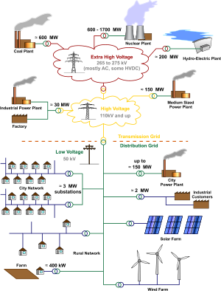](http://en.wikipedia.org/wiki/File:Electricity_Grid_Schematic_English.svg)